**Use JavaScript in adobe forms and display Logo only on first page**

**Please use the previous Demo4_create tables and add the following to it**

1. Go to Tcode SFP .Copy Demo_4 Interface and Form created earlier.

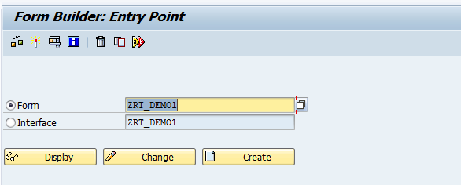

1. Click on Layout. In the Master Page, adjust the content area as shown below.

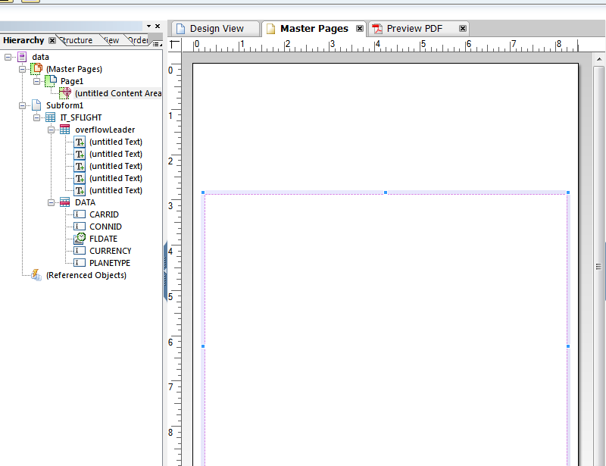

1. In the Master Page, drag and drop Image from Object Library above the Content area

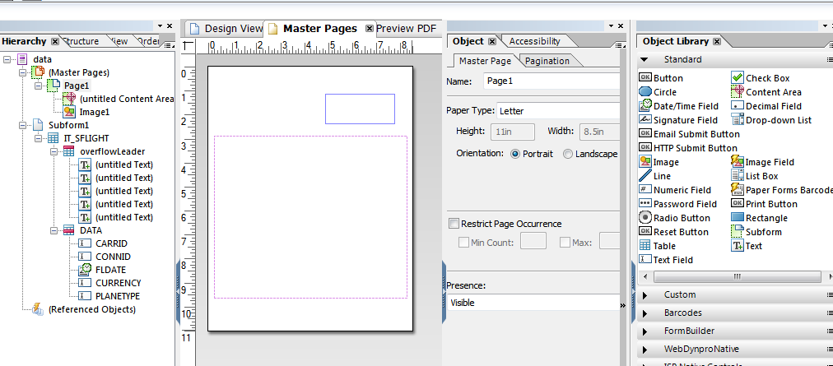

1. In the object window, give the URL of the image **and check on the Embed Image Data**

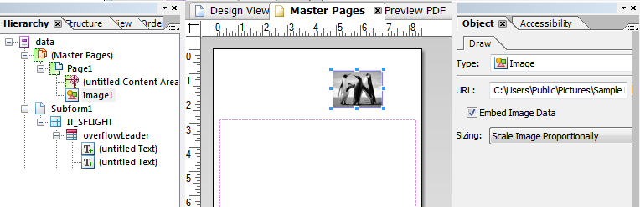

1. In the Hierarchy tab, right click on Image1 and wrap it in sub form as shown below.

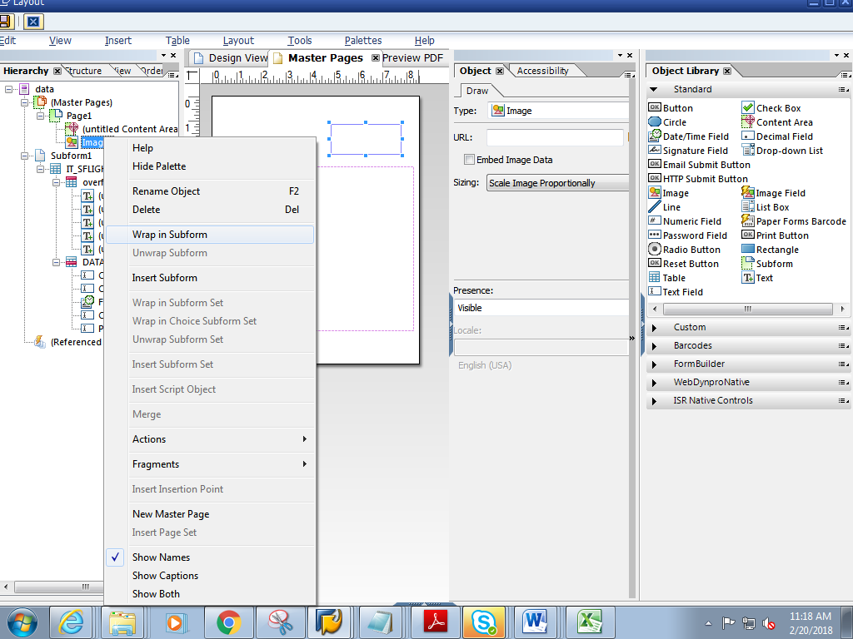

1. In the Hierarchy tab, rename the sub form to **ImageSubform** .In the Object window, choose **Positioned.**

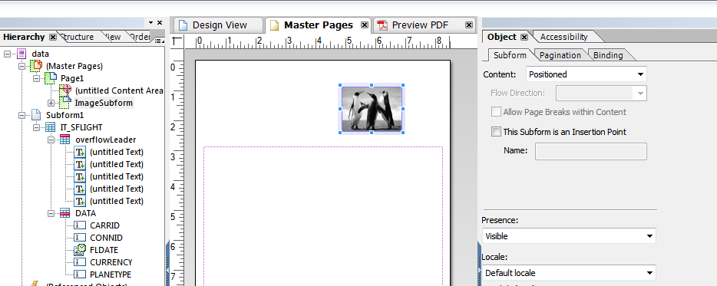

1. Double click on ImageSubform, go to Palettes->Script Editor

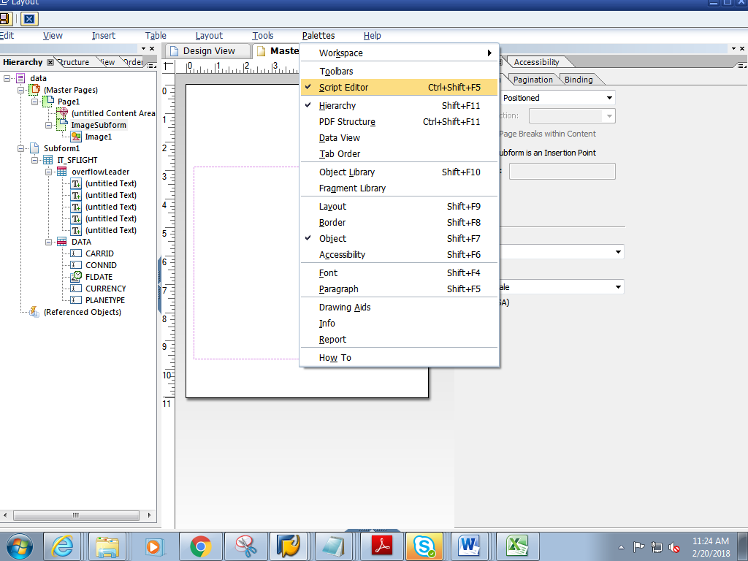

1. In the script Editor , select Show : **Initialise**, Language :**FormCalc** and Run AT as **Client**

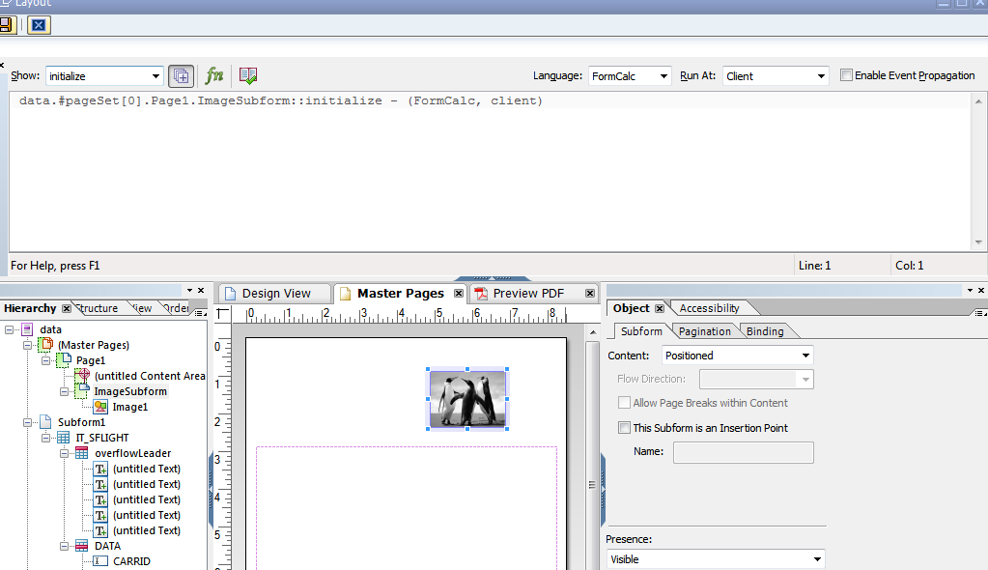

1. Add the below Logic in the script editor.(Note it should be **ImageSubform**::initialize section)

var curpage = $layout.page ( ref ( $ ) )

if ( curpage ne 1 ) then

$.presence = "hidden"

endif

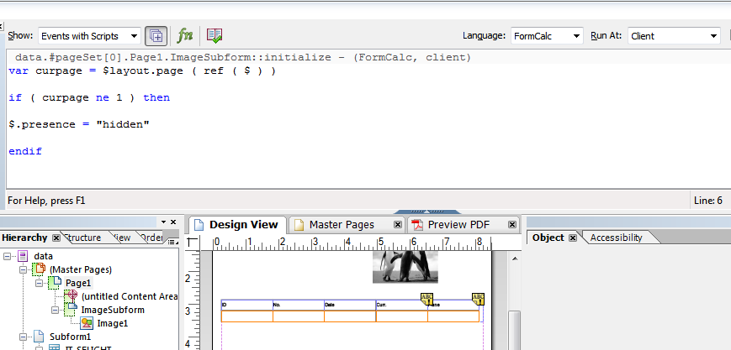

1. Save and close the Layout.
2. Click on context. Save and activate the form
3. Execute the form .Execute the function module

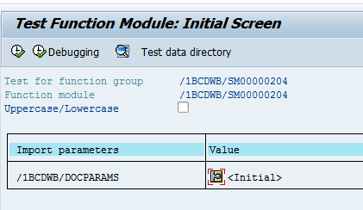

1. Click on Print preview

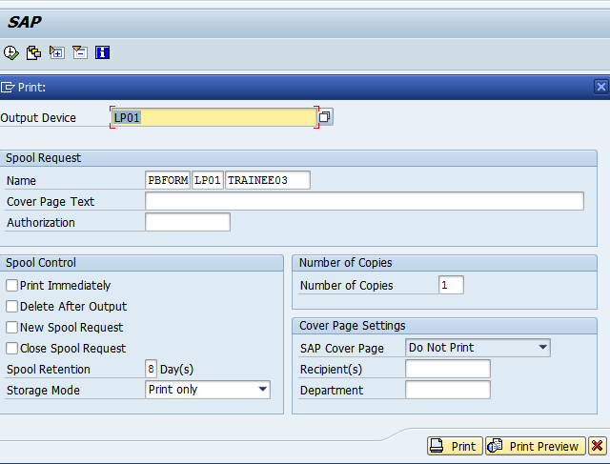

1. Expected output is as follows. Image is displayed only on first page.

